- Create user with name Techie and provide sudo access to user.
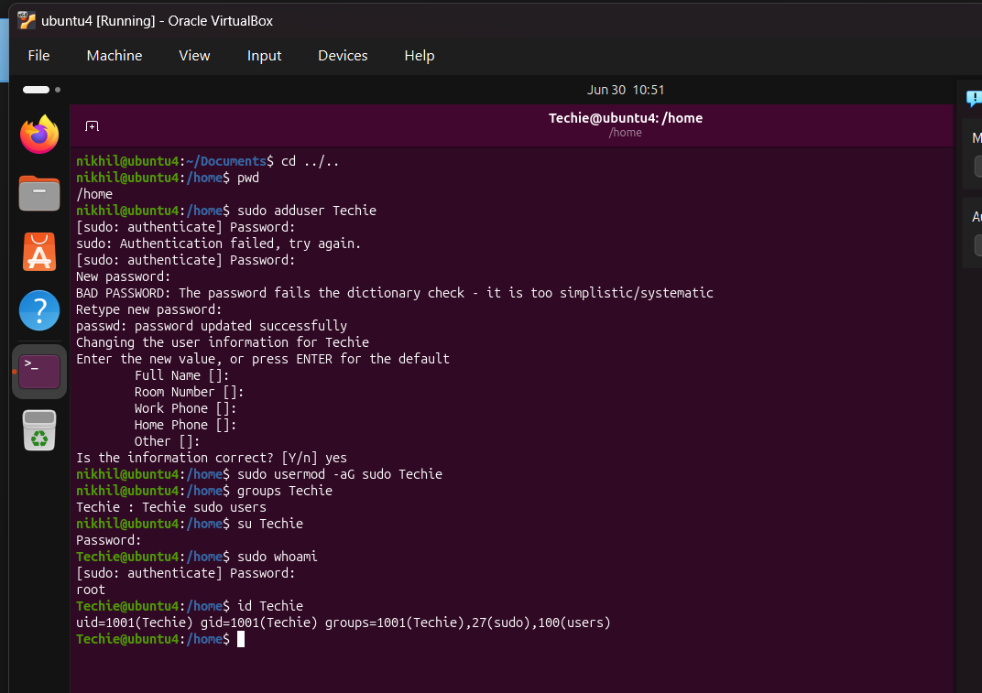 Here user Techie is added with help of command sudo adduser Techie. After that Add the user to the sudo group, using command called sudo usermod -aG sudo Techie. Verify the user is in the sudo group with help of command groups Techie it shows output as Techie : Techie sudo users.
- Navigate to the home directory.
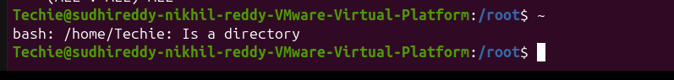
To navigate to the home directory in Linux we use command as cd ~
- Create a new directory.
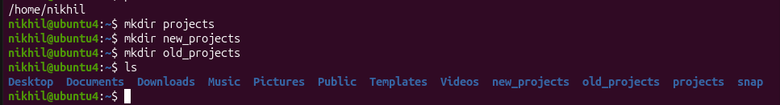
Here created the directories as projects, new projects, old projects using command called mkdir projects
- List the contents of a directory.
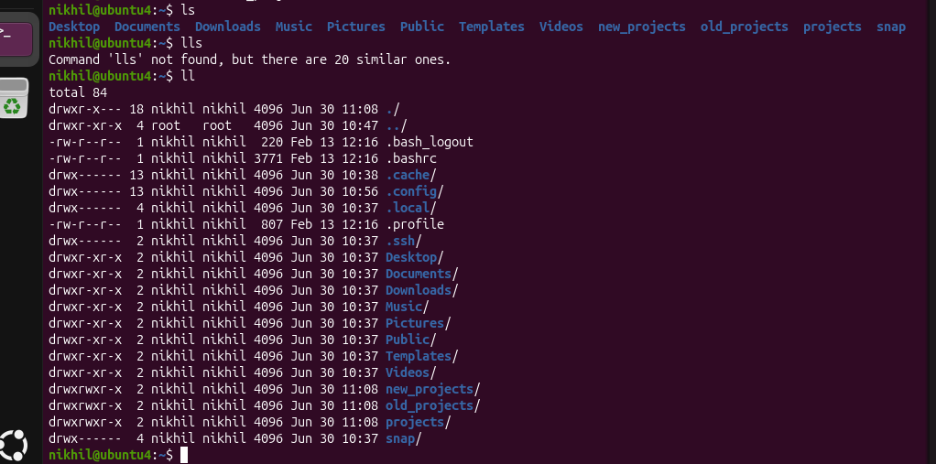
when we want the list of files of current directory we use command called ls. But when we want list along with details then we use command ll.
- Change the current directory
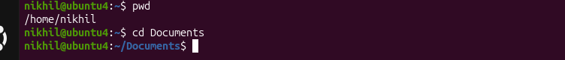
Here we changed the directory nikhil to Documents using command called cd Documents
- Create a new empty file.
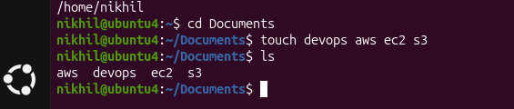
we need to create the files in directory we use command called touch. Here we created the files aws, devops, ec2 and s3.
- View the contents of a file.
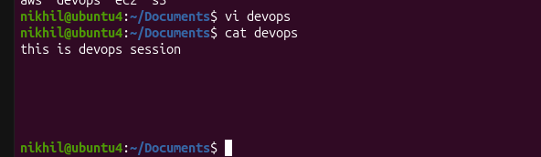
To display the content of file we use command cat filename. Here first we entered text in devops using vi editor. After saving that file and cameout of that file using :qw!. Then used the command called cat devops. It displays the text as this is devops session.
- Copy a file to another location.
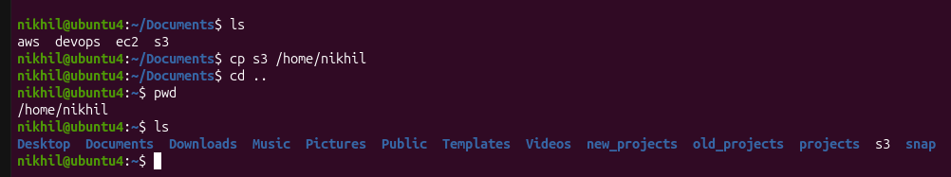
Here we used copy command cp to copy the files. File s3 which is in documents directory is copied into nikhil directory using command called cp s3 /home/nikhil.
- How a file to another location.
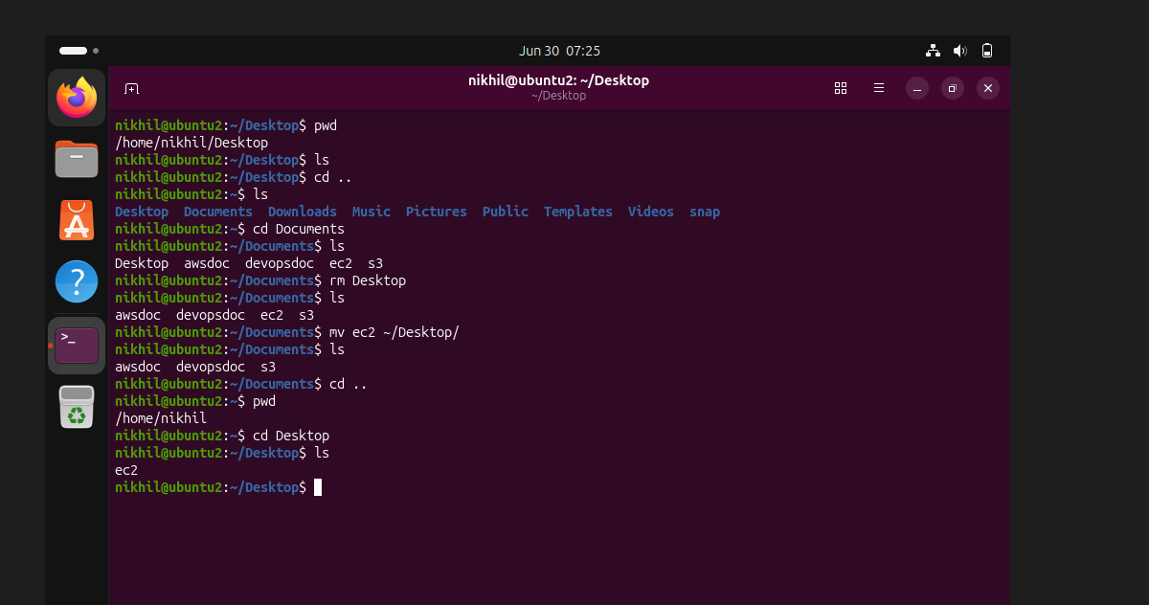
Here the file ec2 which is in directory Documents is moved to the location of directory nikhil using command called mv ec2 ~/desktop/.
- Rename a file.
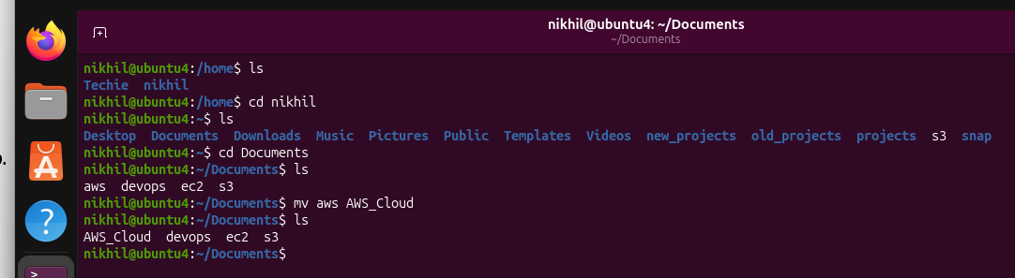
Here the file aws is renamed with AWS_Cloud using command called mv aws AWS_Cloud.
- Delete a file.
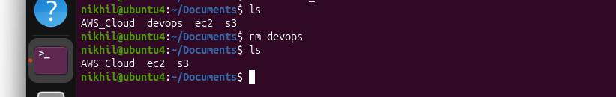
If we need to delete the any file then use command as rm filename. Here we deleted the file devops using command called rm devops, then after listing the files in the current directory using ls command there is no devops file in it.
- Grant or revoke permissions on a file or directory.
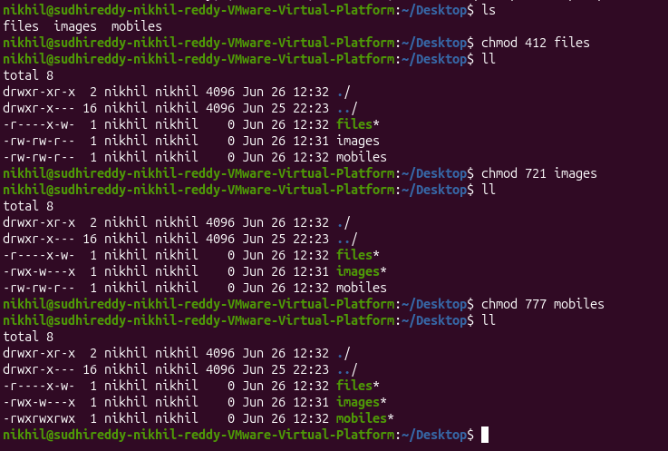
Here files like images, mobiles and files are given permission to read, write and excute. For example file name images has permission like Owner: Read, Write, Execute; Group: Write only; Others: Execute only.
The values are based on:
- Read (r) = 4
- Write (w) = 2
- Execute (x) = 1
For example:
- 7 = 4 + 2 + 1 = rwx
- 5 = 4 + 1 = r-x
- 6 = 4 + 2 = rw-
our ll output correctly reflects the permissions you set with chmod.
- View the current date and time.
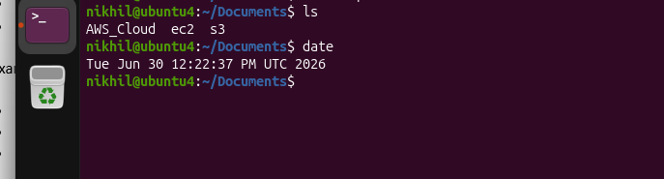To check the date and time we use date command.
- Check the system uptime.
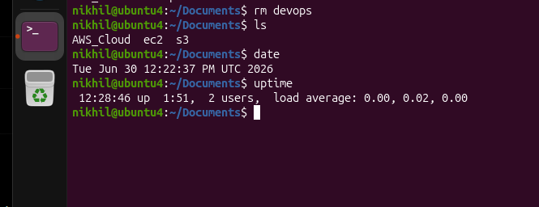
Check the system uptime. Explanation of each field:
Output | Meaning
12:28:46 | Current system time
up 1:51 | The system has been running for 1 hour and 51 minutes since the last boot.
2 users | There are 2 users currently logged in to the system.
load average: 0.00, 0.02, 0.00 | Average CPU load over the last 1 minute, 5 minutes, and 15 minutes.
Understanding the load average
The three numbers represent:
load average: 0.00, 0.02, 0.00
↑ ↑ ↑
1 min 5 min 15 min
0.00 (1 minute): Almost no CPU activity.
0.02 (5 minutes): Very light workload.
0.00 (15 minutes): The system has been mostly idle.
A load average close to 0 indicates the system is not busy.
- View the running processes.
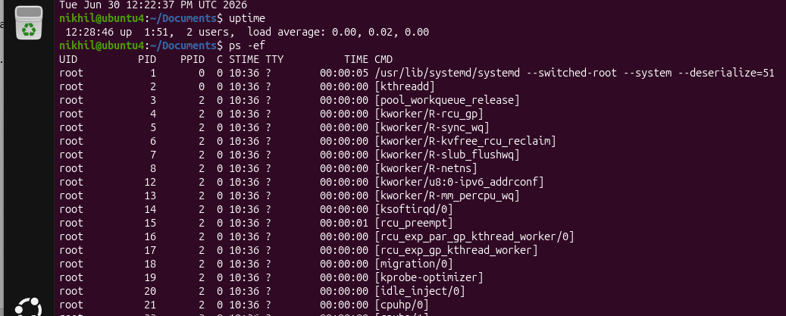
The ps -ef command is one of the most commonly used Linux commands to display information about all running processes on the system.
Explaination

UID | = who owns the process | root

PID | = Process ID (unique identifier) | 1

PPID | = Parent Process ID (the process that started this process) | 0 or 2

C | = CPU usage (scheduler value) | 0

STIME | = Time the process started | 10:36

TTY = | Terminal associated with the process | ? means no terminal

TIME = | Total CPU time used by the process | 00:00:05

CMD | = Command that started the process | /usr/lib/systemd/systemd
- Kill a running process.
The kill command in Linux is used to terminate (stop) a running process. It sends a signal to a process identified by its PID (Process ID).
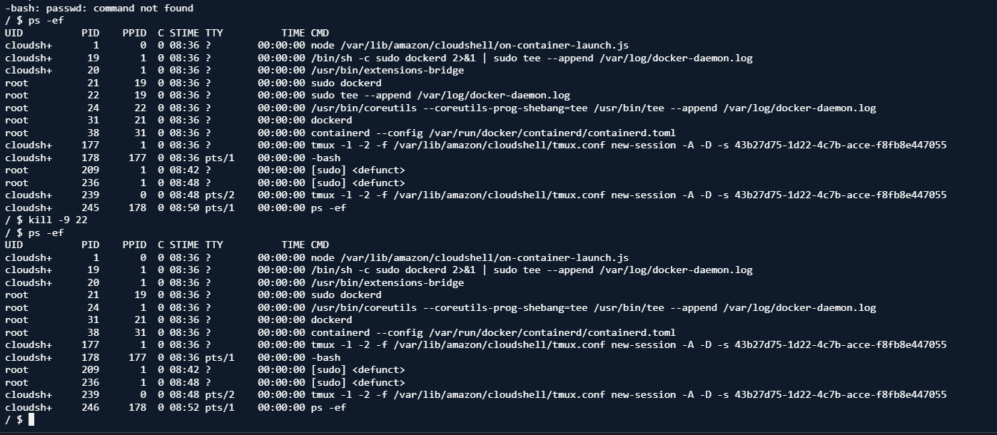
- Install a package using the package manager (e.g., apt or yum).
step 1. Update the package list using command sudo apt update
step 2. Install the package using command sudo apt install nginx.
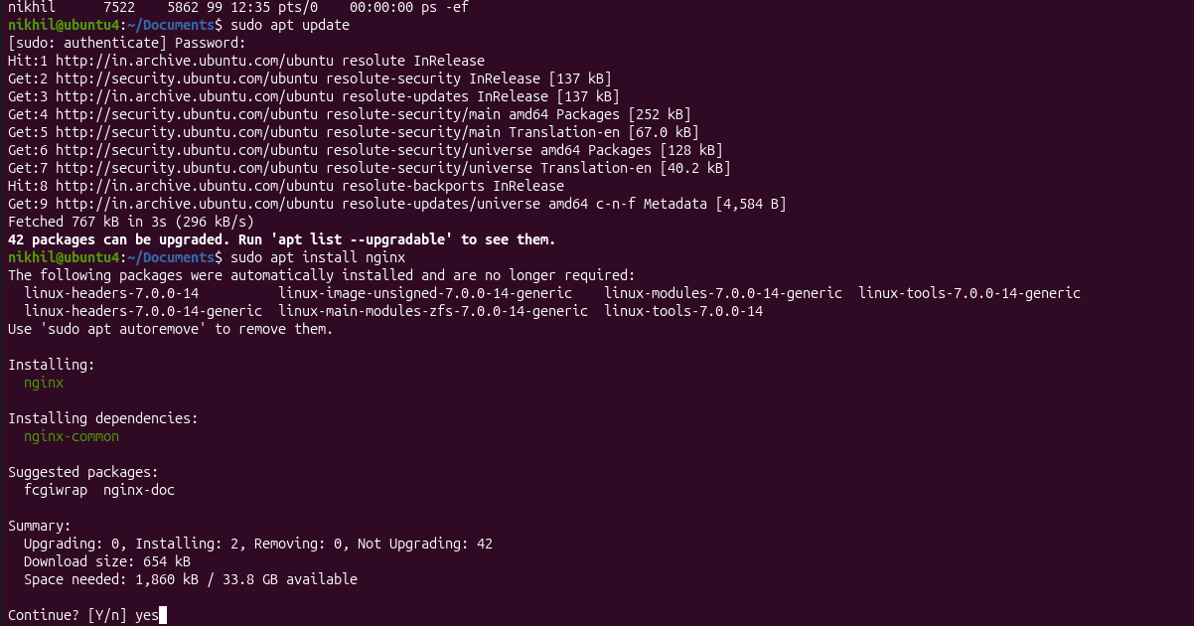
step 3. Check the Nginx service status using command called sudo systemctl status nginx
step 4. Enable Nginx to start at bootusing command sudo systemctl enable nginx
Step 5. Start Nginx service using command called sudo systemctl start nginx.
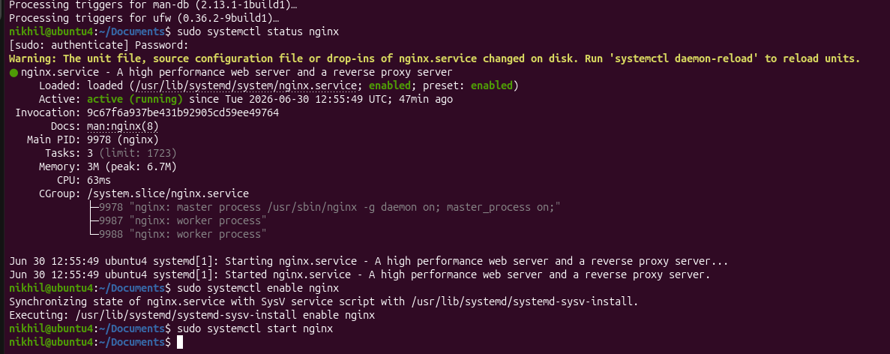
step 6. Stop nginx service using command called sudo systemctl stop nginx
above are the steps to install Nginx, verify that it's running, and configure it to start automatically when the system boots.
- Update the system packages.
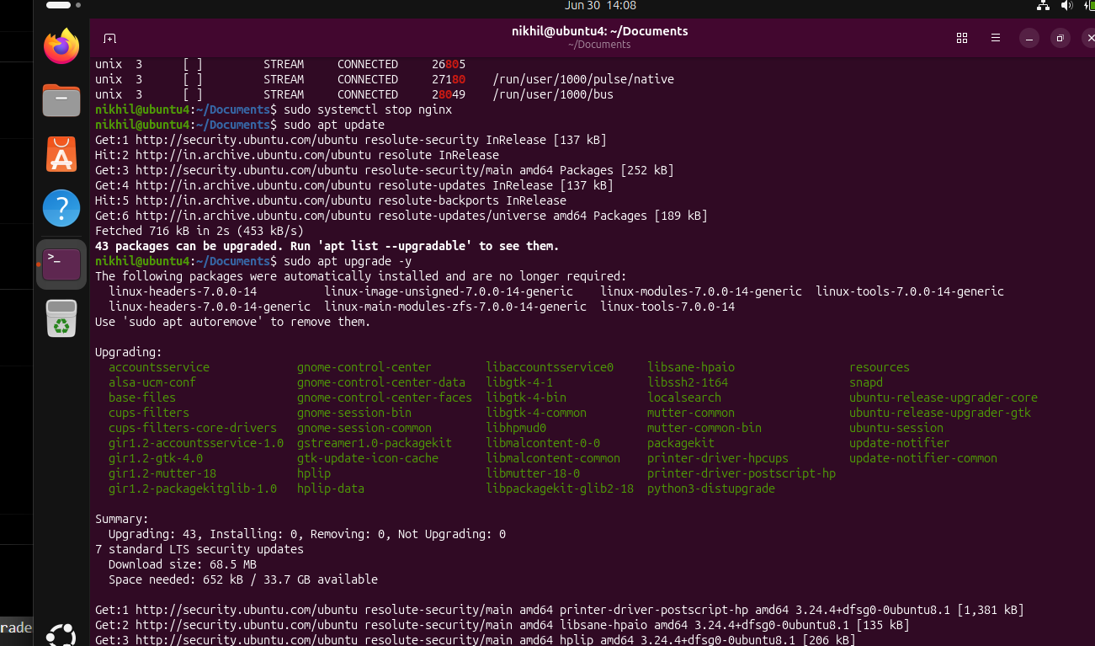
step 1. Update the package list
sudo apt update
What it does:
- Downloads the latest information about available packages from the configured repositories.
step 2. It does not install or upgrade any packages
Upgrade installed packages
sudo apt upgrade -y
What it does:
- Upgrades all installed packages to their latest available versions.
- The -y option automatically answers Yes to the confirmation prompt.
Remove unused packages using command sudo apt autoremove -y
Clean the package cache sudo apt autoclean.
19. Create a symbolic link.
A symbolic link (soft link) is a special file that points to another file or directory. It works like a shortcut in Windows.
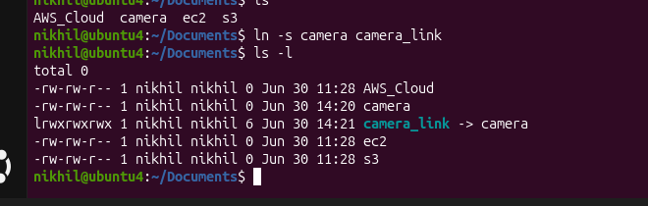
l at the beginning (lrwxrwxrwx) indicates a symbolic link.
-> camera shows that camera_link points to camera.
20. Search for files using the find command.
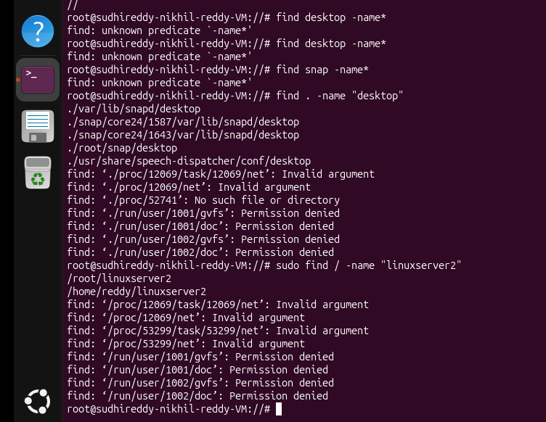
To search the files which are located at unknown location we use find command as find / -name “filename”.
For example we need location of file linuxserver2 then we use command as find /name “linuxserver2”. The output of result shows path as /home/reddy/linuxserver2.
21. Compress and decompress files using tar. 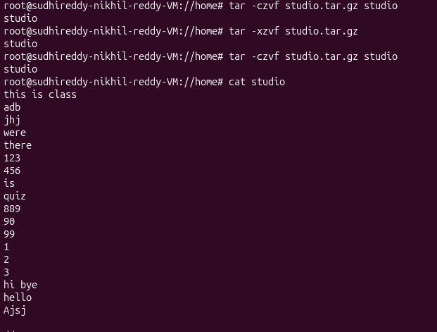
here File studio is compressed and decompressed 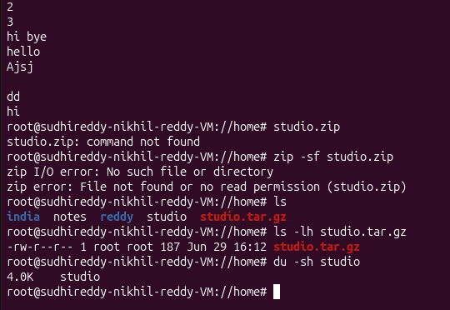
This line from command shows that original studio directory is currently contains a tiny amount of text (4 kilobytes), which explains the file compressed as 187bytes.
22. Monitor system resources with top or htop.
It is used get the usage of cpu.
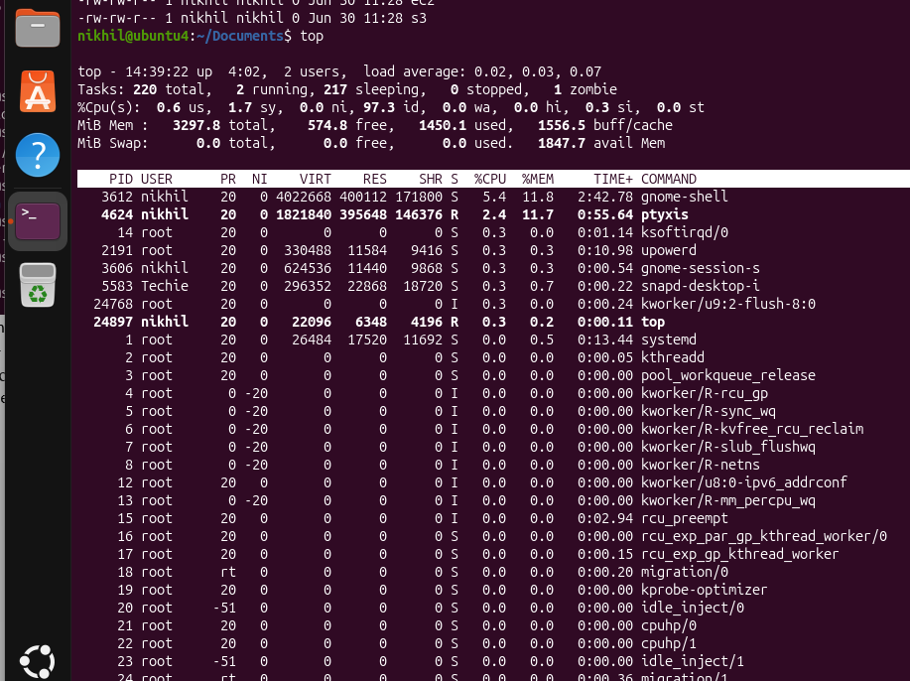
23. Create and manage user groups.
In Linux, a group is a collection of users. Groups are used to simplify permission management by assigning permissions to the group instead of individual users.
Here group was created with name devops. After that need to verify the group was created or not.
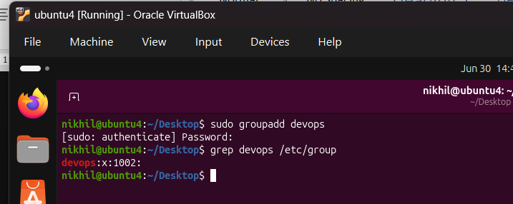
groupadd groupname | - Create a new group

groupdel groupname | - Delete a group

groupmod -n new old | - Rename a group

groups username - | Which group user belongs

id username - | Display user and group IDs

usermod -aG group user - | Add a user to a supplementary group

gpasswd -d user group - | Remove a user from a group
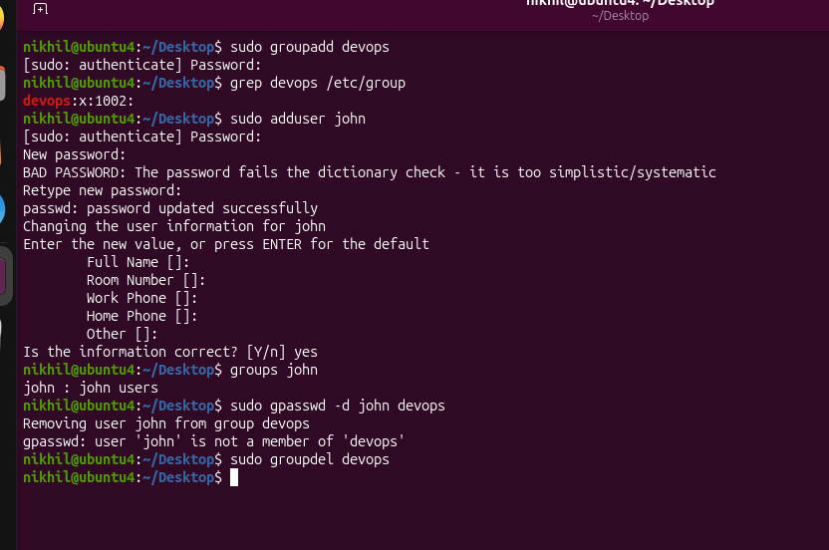
Here user john was added before group was created with name devops. And added user to the group with command sudo usermod -aG devops john. And verified the group using groups john. At last removed the user john from group devops with command sudo gpasswd -d john devops.
finally deleted the group devops using command called sudo groupdel devops.
24. Set up SSH password less authentication.
SSH passwordless authentication allows you to log in to a remote Linux server without entering a password by using SSH key pairs.

Prerequisites
- Two Linux machines (or VMs):
  - Client (from where you connect)
  - Server (to which you connect)
- SSH server installed on the remote machine.
- Network connectivity between the two machines.
Step1. Check if the SSH server is installed on the remote machine using command sudo systemctl status ssh.
Expected output : Active: active (running)
step2. Find the IP address of the remote machine using command hostname -I 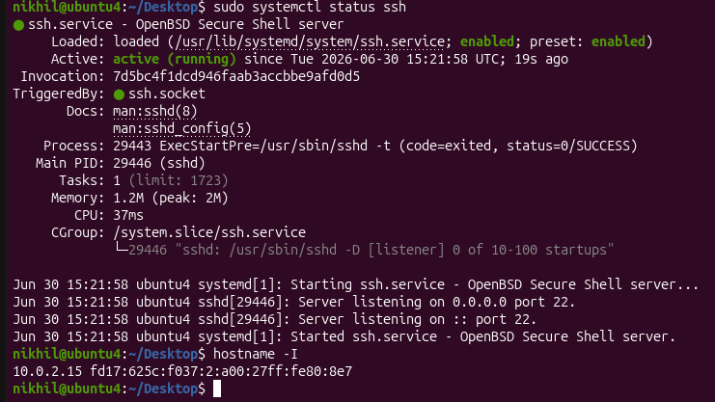
step3. Generate an SSH key pair on the client machine.
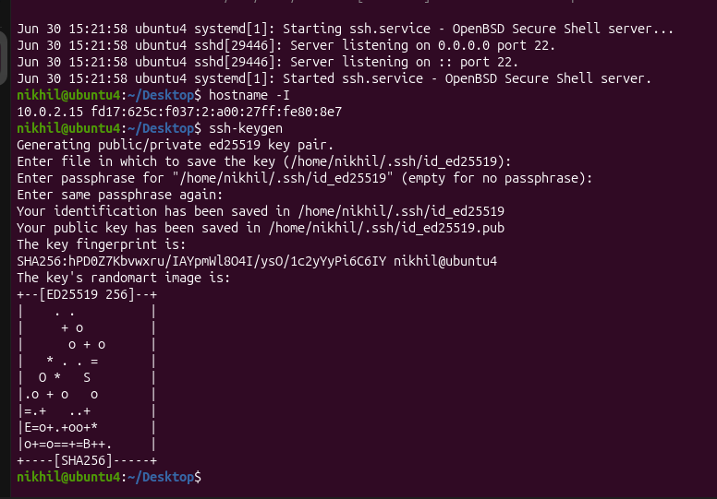
step4. Verify ssh keys using command ls -ls ~/.ssh
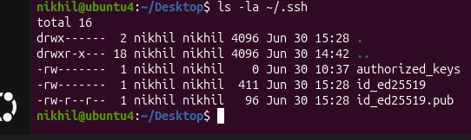
step5. Copy the public key to remote server with command ssh-copy-id username@ip
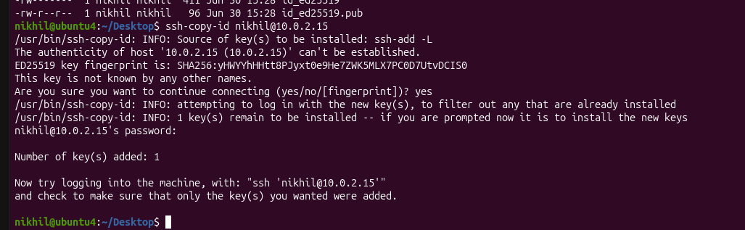
step6. Test passwordless login using command called ssh nikhil@10.0.2.15
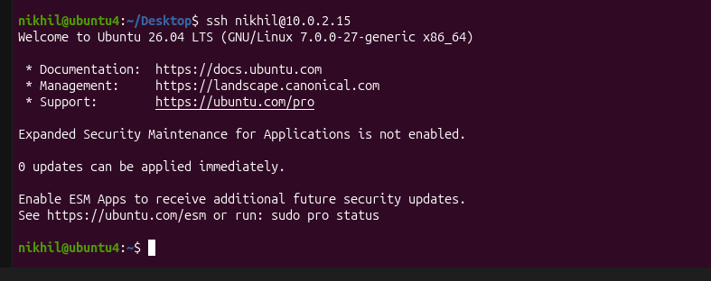
step7. Verify the public key on the server using command cat ~/.ssh/authorized-key
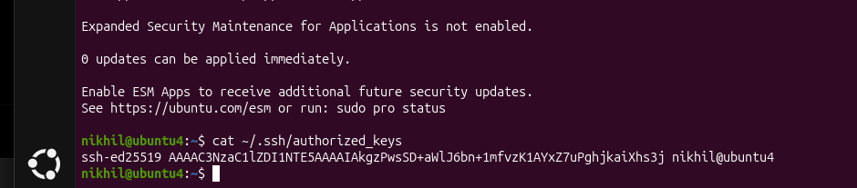
These steps are the standard approach used by Linux administrators and DevOps engineers to configure SSH passwordless authentication.
25. Monitor log files using tail or grep.
Linux administrators use the tail and grep commands to monitor log files in real time and search for specific messages such as errors, warnings, or login attempts.
To stop monitoring press ctrl+c.
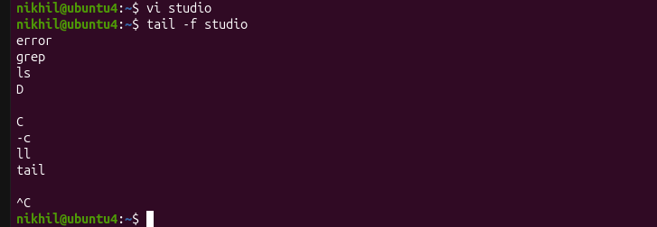
In the above snap shows the last 10 lines of file studio using command tail -f studio.
Search for a keyword monitor using command grep monitor studio
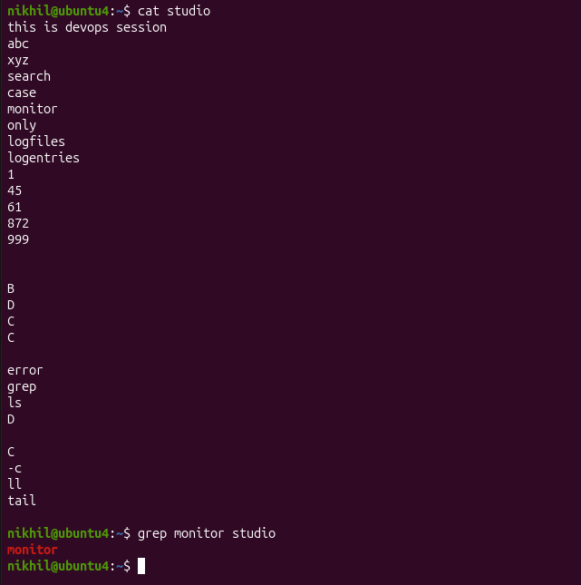
26. Set up a web server (e.g., Apache or Nginx).
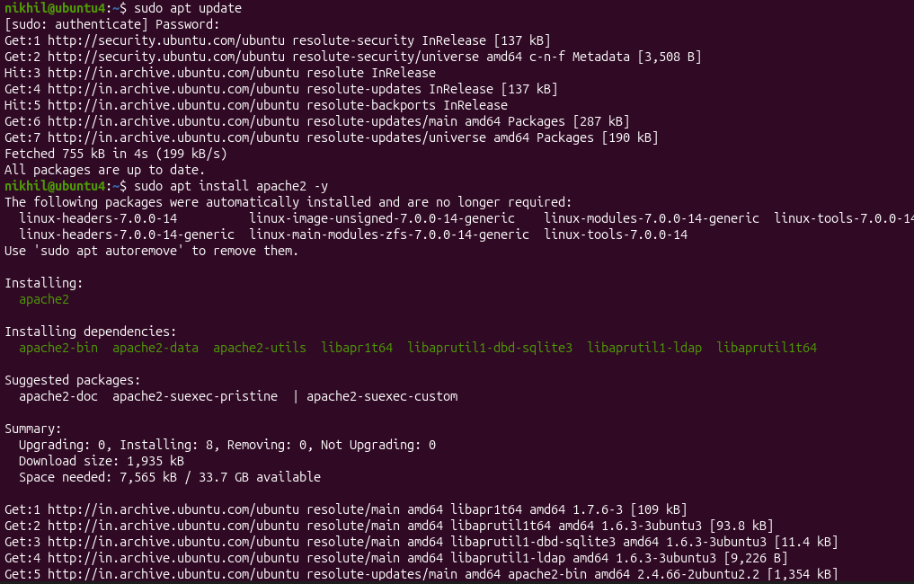
need to install apache2 server
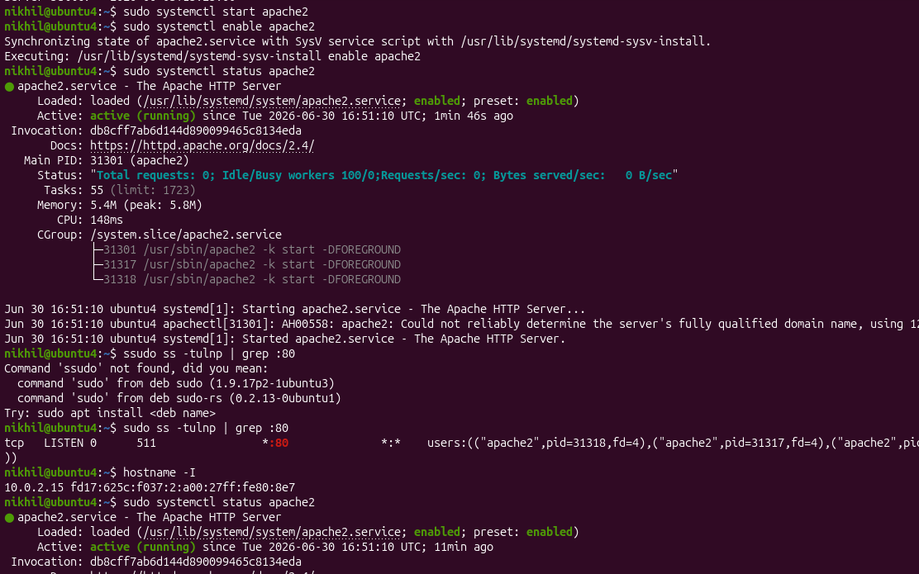
check version of apache2 server
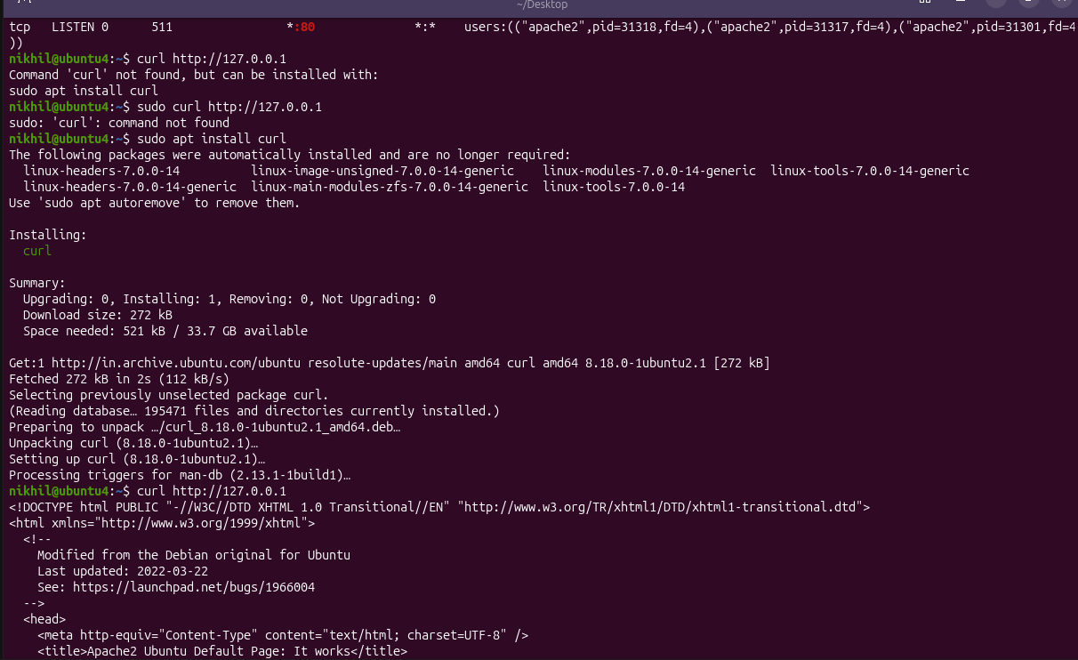
Test the apache2 server in browser
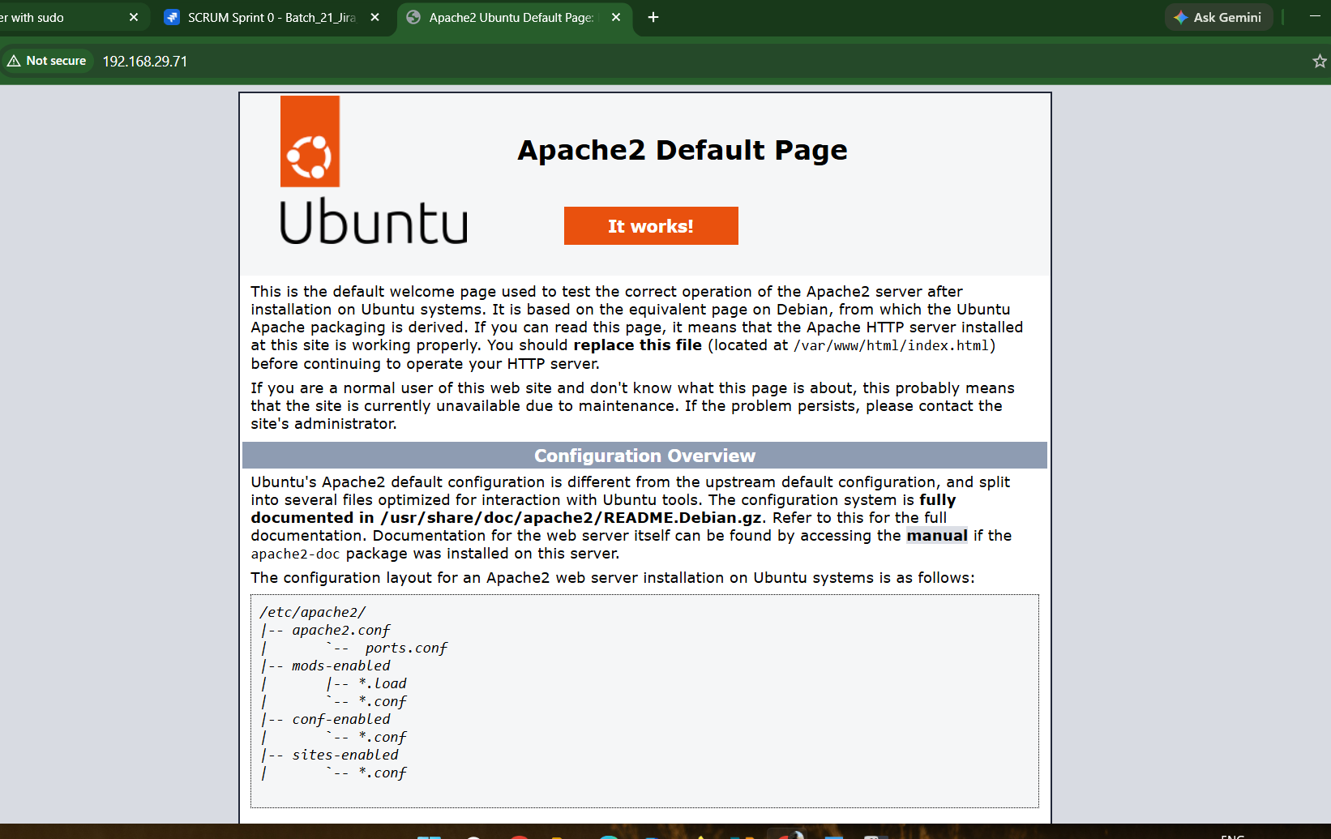
restart the service 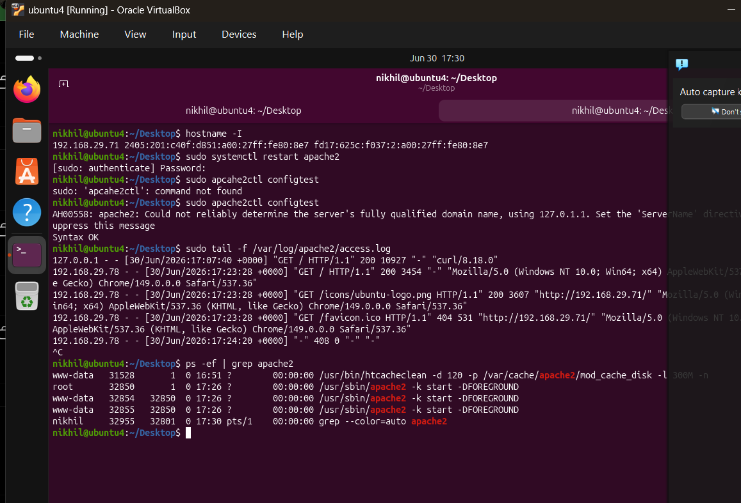
Update the packages list
Install apache2
Verify the Apache Installation
Start the Apache Service
Enable Apache to Start at Boot
Check the Apache Service Status
Verify Apache is Listening on Port 80
Find the Server IP Address
Test the Apache Web Server
Create Your Own Web Page
Restart Apache
Verify the Apache Configuration
Monitor Apache Log Files
Verify the Apache Process
27. configure and secure a MySQL database
. 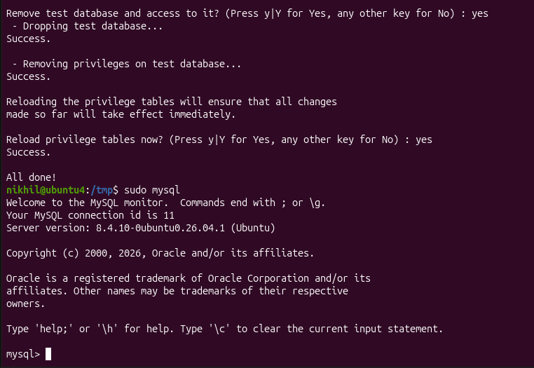

28 . Set up a Application Server (e.g.,Apache Tomcat)
• Update the System Packages
• Install Java (OpenJDK)
• Verify the Java Installation
• Create a Dedicated Tomcat User
• Download Apache Tomcat
• Extract the Tomcat Archive
• Move Tomcat to the Installation Directory
• Set Ownership and Permissions
• Create a Tomcat Systemd Service
• Start and Enable the Tomcat Service
• Verify the Tomcat Service Status
• Allow Port 8080 Through the Firewall (if UFW is enabled)
• Access the Tomcat Web Interface
• Configure Tomcat Manager and Host Manager Access
• Deploy a Sample Web Application (WAR File)
• Monitor Tomcat Logs
• Verify the Tomcat Process
• Restart, Stop, and Reload Tomcat Services
• Test the Application Server
• Troubleshoot Common Tomcat Issues
  - create a service file for Apache Tomcat.(Should execute by using systemtctl command) 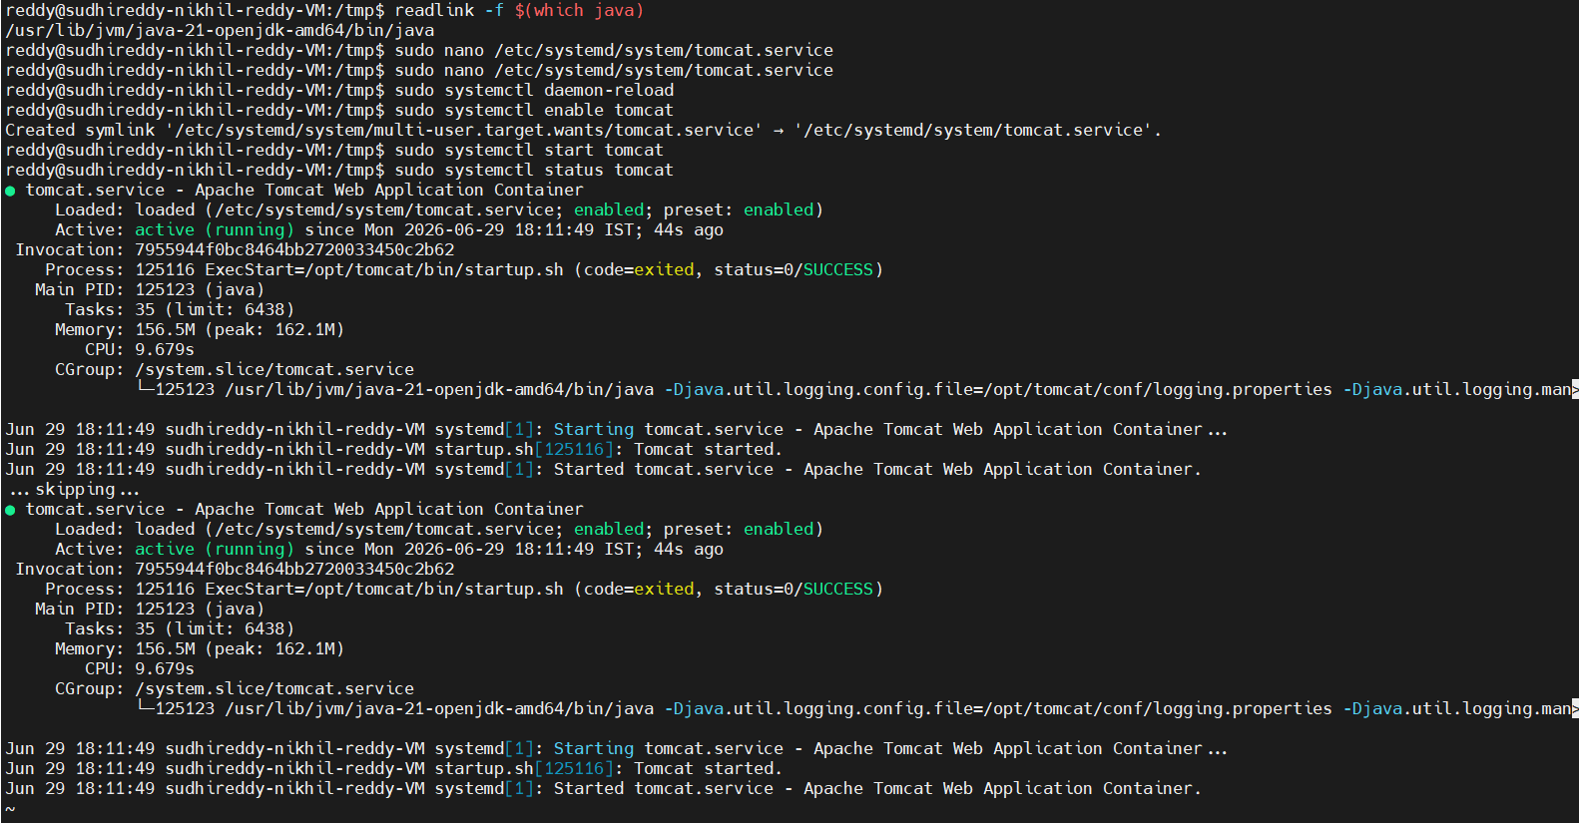 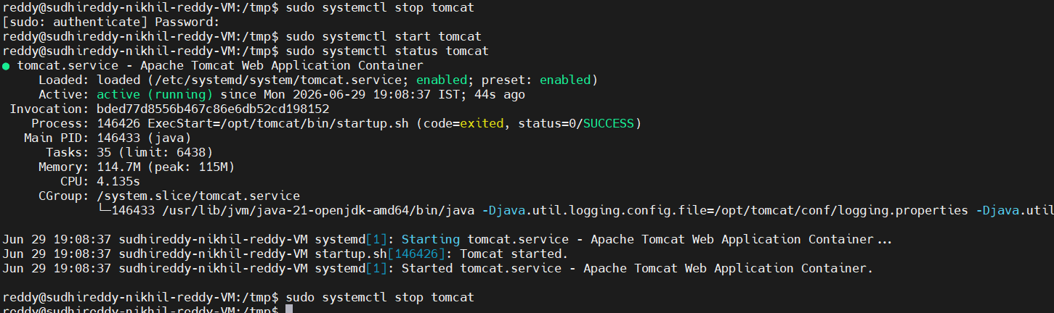
  - Print specific columns from a delimited file.
The cut command is commonly used to print specific columns from a file using a delimiter such as a comma (,), colon (:), or tab.
To print first column use command called cut -d ":" -f1 filename.
To print multiple columns use command cut -d ":" -f1,2 filename.
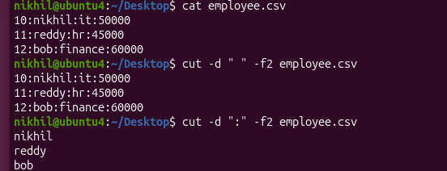
  - Filter and print lines based on a specific pattern or condition.
To display lines matching a specific pattern. In Linux, the grep command is used to search and print lines that match a specific pattern. 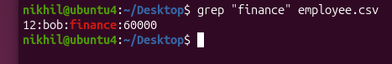
  - Calculate and print the average, sum, or other statistics of a column.
In Linux, the awk command is commonly used to perform calculations on columns.
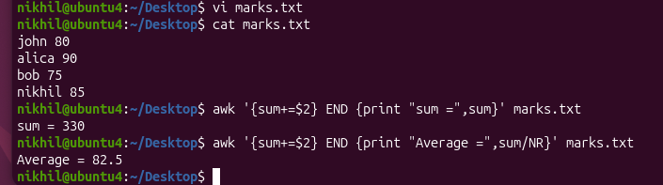
Commands used as
Average: awk -F '{sum+=$2} END {print “Average =” ,sum/NR}' marks.txt
Sum: awk -F '{sum+=$2} END {print “sum =”,sum}' marks.csv
  - Perform string manipulation, such as extracting substrings or changing case.
Linux provides commands like cut, awk, tr, sed, and Bash parameter expansion to manipulate strings.
using command tr we change lower case to upper.
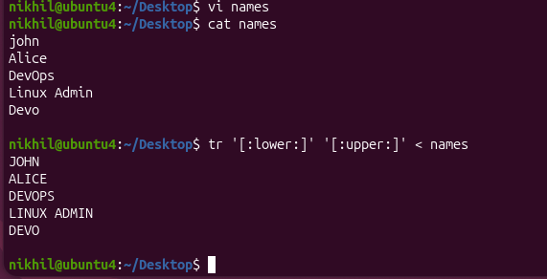
using command sed we can replace the part of string. To Count the number of characters in an word we wc command.
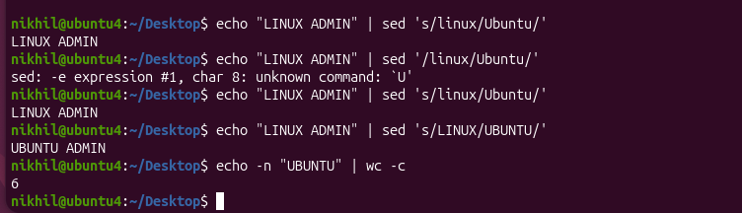
  - Count the occurrences of a specific pattern in a file.
Count occurrences of specific keyword using grep command.
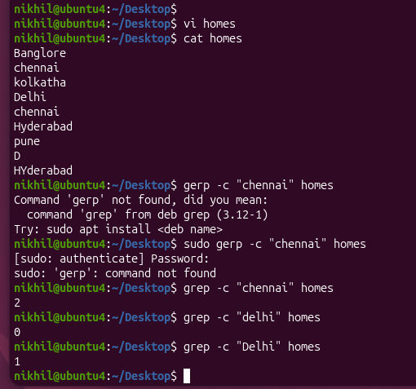
Here the word Chennai as appeared 2 times and delhi 1 times.
commands used are grep -c “Chennai” homes
grep -c “Delhi” homes
  - Sort lines based on a specific field or column.
To Sort by Employee ID (1st column) using sort -t “:” -k1 employee.csv
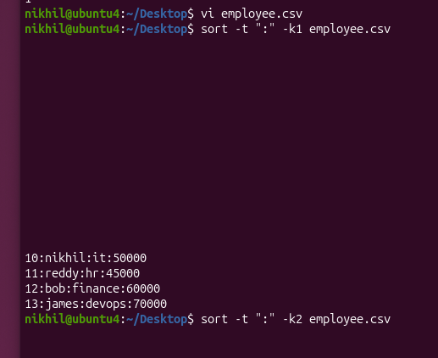
To Sort by Salary in Descending Order using command sort -t “:” -k4 -nr employee.csv
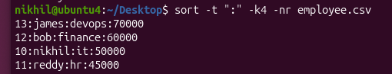
  - Merge multiple files based on a common field or column.
In Linux, the join command is used to merge two sorted files based on a common field (column).
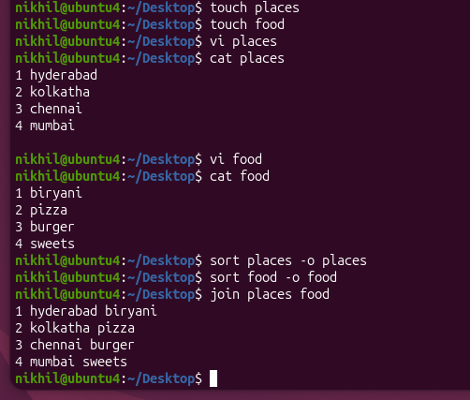
  - Substitute text in a file using search and replace.
create a two files examples places and food
we can replace the text of biryani with veg biryani as below snip
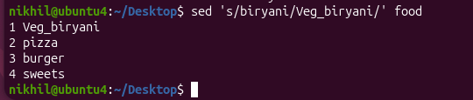
To Display replacement only sed 's/old/new/' filename
For Permanent replacement sed -i 's/old/new/' filename
To Replace all occurrences sed -i 's/old/new/g' filename
To Replace only on line 3 sed '3s/old/new/' filename
  - Delete specific lines based on a pattern or line number.
To delete a specific line we use command sed
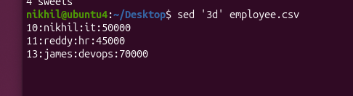
Here we deleted the line 3 in employee.csv file using sed ‘3d’ employee.csv
  - Append or insert text before or after a specific pattern or line.
The sed (Stream Editor) command can be used to insert or append text relative to a specific line number or a matching pattern.
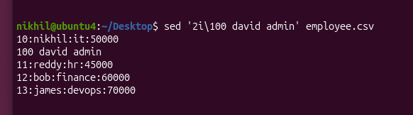
Here we added the line 100 david admin using sed ‘2i\100 david admin’ employee.csv
  - Print only specific lines from a file.
In Linux, you can print specific lines from a file using commands such as sed, head, tail, and awk.
print only for one line using sed command sed -n '3p' employee.csv
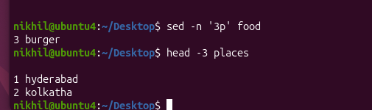
To print 3lines of a file places used command as head -3 places
  - Copy file from linux to windows machine.
To copy a file from Linux to your Windows machine using MobaXterm Let's use employee.csv as an example.
Step 1: Check the current path pwd Output: /home/nikhil
Step 2: Verify the file exists ls -l employee.csv or cat employee.csv
Step 3: Download the file Since you're using MobaXterm:
1. Look at the left side of the MobaXterm window.
2. You'll see the SFTP panel.
3. Open the folder home nikhil.
4. Find employee.csv.
5. Drag and drop it to your Windows Desktop or any folder.
OR • Right-click employee.csv • Select Download • Choose the destination folder in Windows.

  - 5 use cases for AWK and 5 use cases for sed:
5 use cases for AWK

1.Print specific columns from CSV or text files.

2. Filter records based on a condition.

3. Calculate the sum, average, minimum, or maximum of a column.

4. Perform string operations such as converting text to uppercase/lowercase or extracting substrings.

5. Generate formatted reports from log files or structured data.

5 use cases for sed:

1. Search and replace text in a file.

2. Delete lines based on a line number or pattern.

3. Insert or append text before or after a specific line.

4. Print selected lines from a file.

5. Edit configuration or log files automatically without opening a text editor

